How to verify a Tendermint core node only has one cosmos account(also can be called validator, validator operator)?

Date: 15/07/2019

Step 1：install gaia and tendermint

System: Ubuntu 16.04 LTS

GO version: go1.12.7 linux/amd64

Tendermint version: 0.32.0-378a0e51

Gaia version: v0.34.x

Gaia install instruction: <https://github.com/cosmos/gaia/blob/master/docs/installation.md>

Tendermint install instruction: [https://tendermint.com/docs/introduction/install.html#from-binary](https://tendermint.com/docs/introduction/install.html" \l "from-binary)

if you meet problem when installing gaia using command “make install”, please recheck if go version, path, and root is right.

Step 2: Add an account and types of address

Use command line: $ gaiacli keys add [account_name]

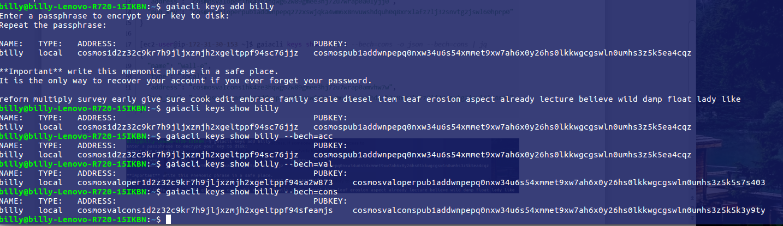

Fig.1-Add account

There are three different types of addresses, but they are created by the same node. As follows is the address type from Cosmos-sdk/Docs/spec/bech32.md

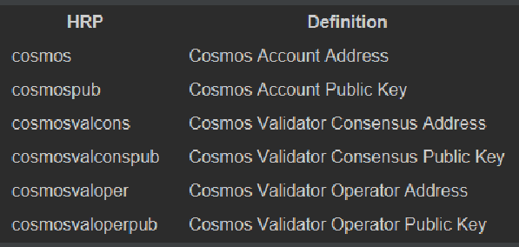

Fig.2-Address type

But these address are defined in cosmos network layer, there is still another address in Tendermint core layer.

Using Cosmos Block 1053800(Height) for example, on official website, the information of proposer is as follows:

Operator Address

cosmosvaloper14lultfckehtszvzw4ehu0apvsr77afvyju5zzy

Self-Delegate Address

cosmos14lultfckehtszvzw4ehu0apvsr77afvyhgqhwh

Then, in swagger UI (https://cosmos.network/rpc), search for the latest block, extract the block height and proposer’s address.

Height: 1053800

|  |  |
| --- | --- |
| proposer_address | "2199EAE894CA391FA82F01C2C614BFEB103D056C" |

Proposer’s address is a tendermint core consensus address.

Step 3: Add another account

The same step as Step 2.

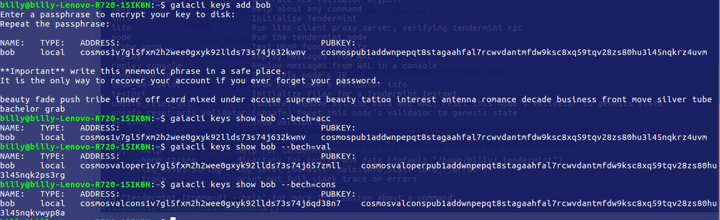

Fig.3-Add another account



Fig.4-Key lists

Step 4: display node info by Tendermint

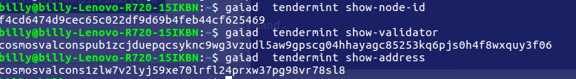

Fig.5-Node information

One node Id only has one account address (also means it has one validator, validator operator) according to the Fig.5.